

Capstone Project Report
Report 6 – Software User Guides

– HoChiMinh, April 2025 –
Table of Contents
I. Record of Changes. 3
II. Release Package & User Guides. 4
1. Deliverable Package. 4
2. Installation Guides. 4
2.1 System Requirements. 4
2.2 Installation Instruction. 4
3. User Manual 4
3.1 Overview.. 4
3.2 Workflow 1. 4
3.3 Workflow 2. 4

I. Record of Changes
Date | A*  M, D | In charge | Change Description
*A - Added M - Modified D - Deleted

II. Release Package & User Guides

1. Deliverable Package
No. | Deliverable Item | Description
1 | Schedule/Task Tracking | Modify
2 | Project Backlog | Modify
3 | Source Codes | Modify
4 | Database Script(s) | Modify
5 | Final Report Document | New
6 | Test Cases Document | New
7 | Defects List | New
8 | Issues List | New
9 | Slide | Modify

2. Installation Guides

2.1 System Requirements
Client Applications
Mobile application (React Native)
Web application (Next.js)
Server: VPS running Ubuntu Server
Database:MongoDB
File Storage:Firebase (Google Firebase)
Operating Systems: MacOS, Microsoft Windows.
Frameworks & Versions:Node.js: v20.1.1,Next.js: 15.1.1,React Native: 0.76.7,NestJS: Latest version compatible with Node.js 20+

2.2 Installation Instructions
Visual Studio Code
Download and install from: https://code.visualstudio.com/download

Android Studio (for React Native development)
Download and install from: https://developer.android.com/studio

Nodejs
Download and install Node.js v20.1.1 from: https://nodejs.org/en/download

project installation:
Vin Shuttle

Backend installation:
Step 1: Download code package in GitHub via link
Step 2: open project with terminal (macOS) or cmd (Win10)
● Redirect to the path of the project (using cd *path)
● Run an app in Visual Studio ( recommended) (using code .)
Step 3: Open terminal in Visual Studio and Install all modules with command line “npm install”.
Step 4: Run “npm run start” to start the project.

Frontend installation:
Step 1: Download code package in GitHub via link
Step 2: open project with terminal (macOS) or cmd (Win10)
● Redirect to the path of the project (using cd *path)
● Run an app in Visual Studio ( recommended) (using code .)
Step 3: Open terminal in Visual Studio and Install all modules with command line
cd frontend-customer or cd frontend-admin
“npm install”.
Step 4: Run “npm run dev” to start the project.

3. User Manual

3.1 Overview

Workflow 1: Booking by hours
Workflow 2: Booking by scenic route
Workflow 3: Booking by destination
Workflow 4: Booking share

3.2 Workflow 1: Booking by hours
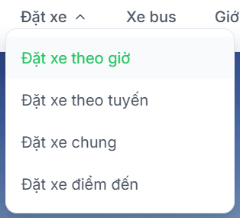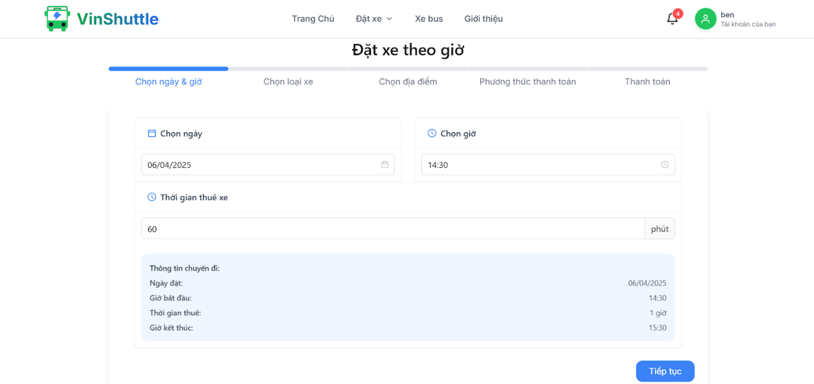
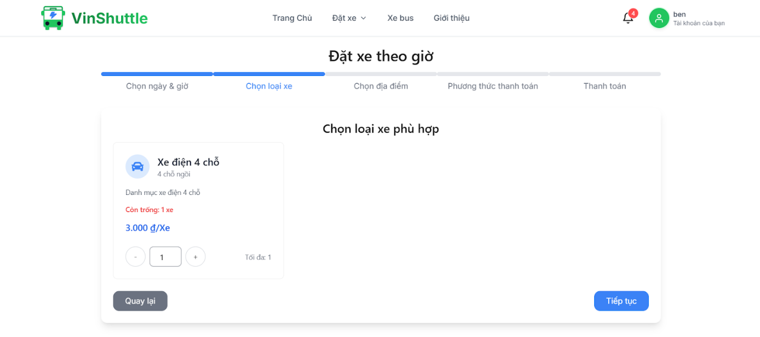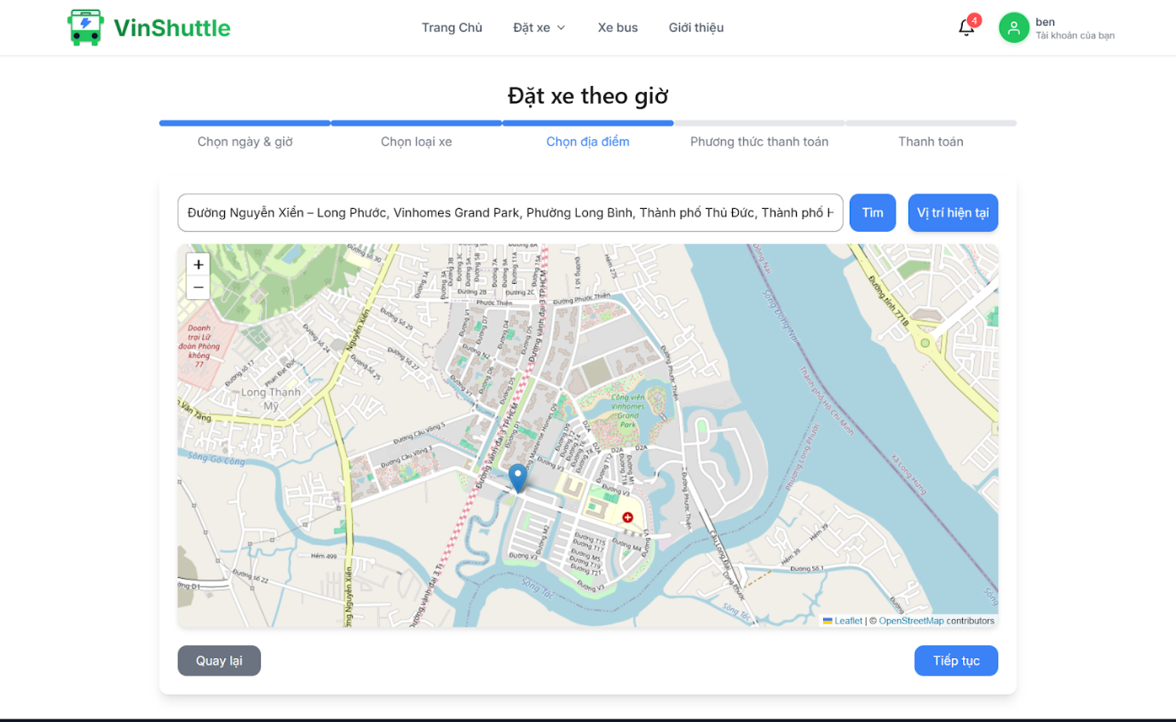
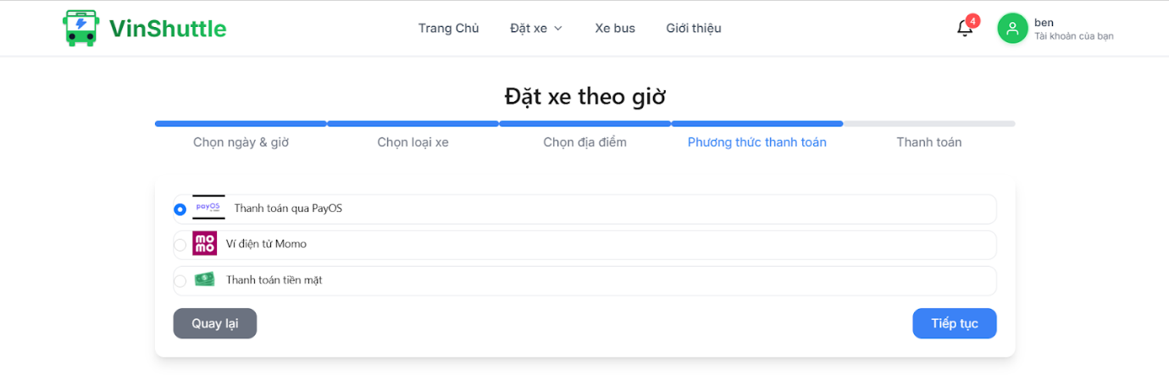
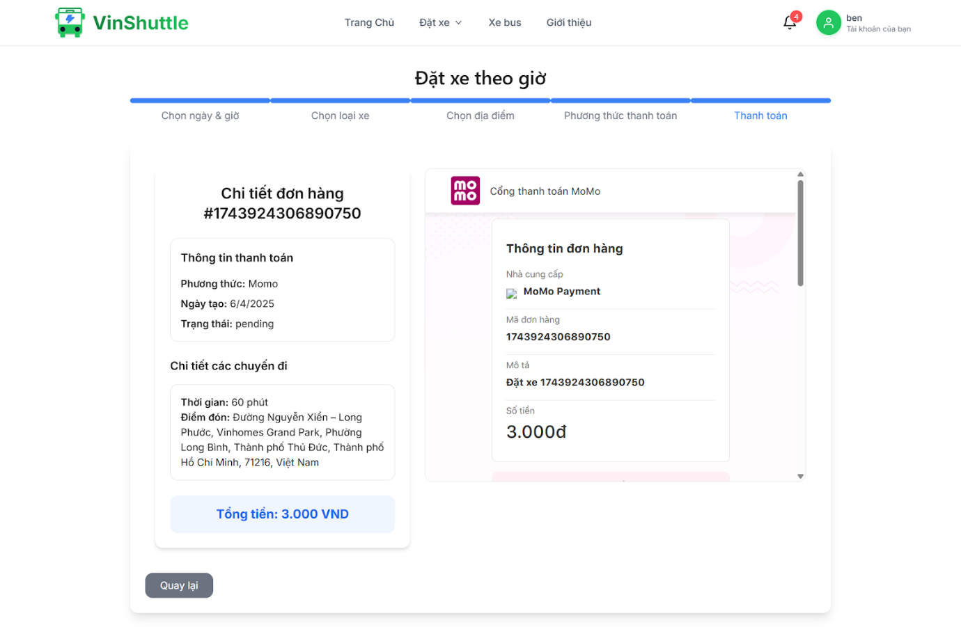
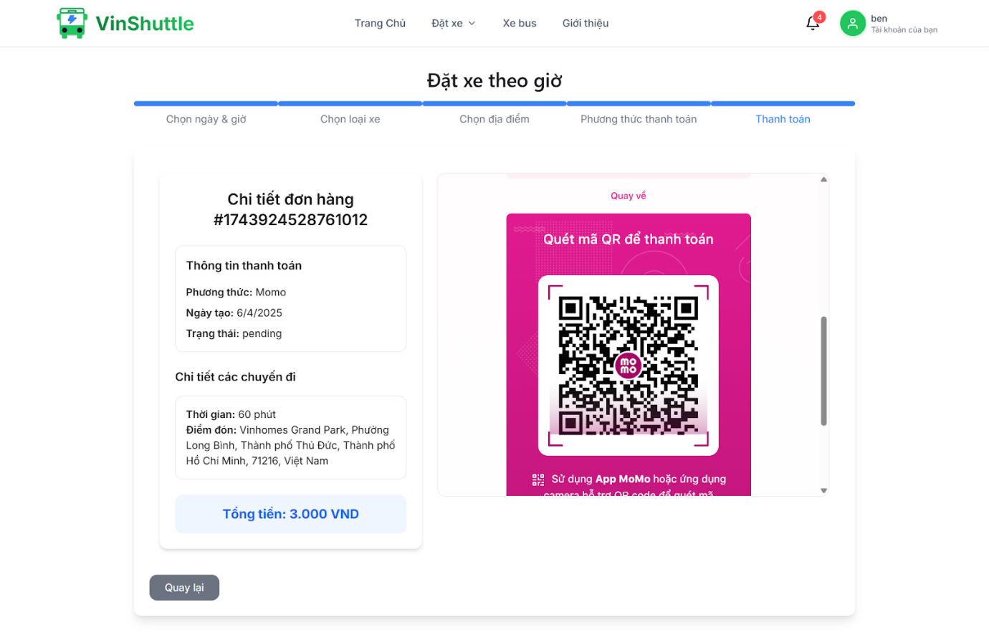
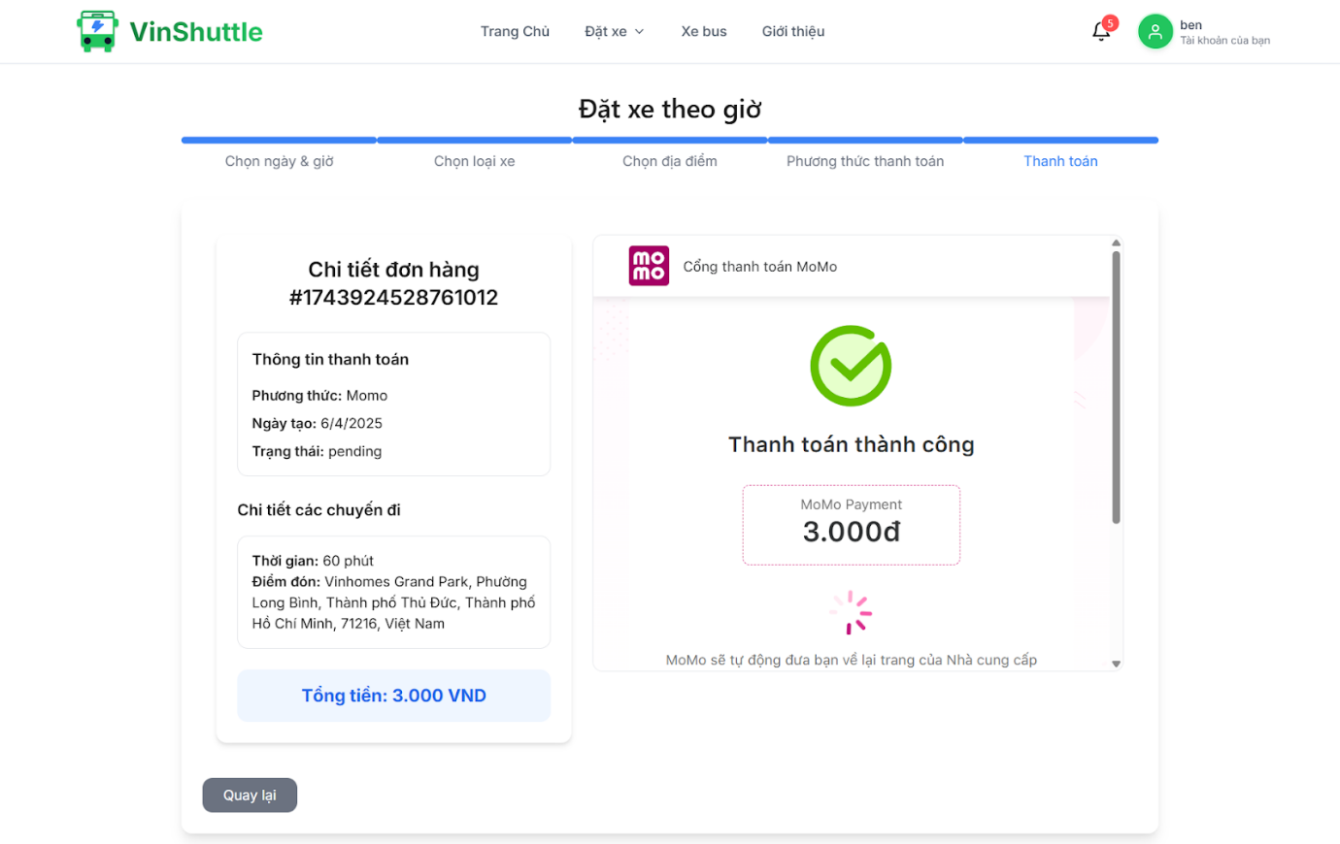
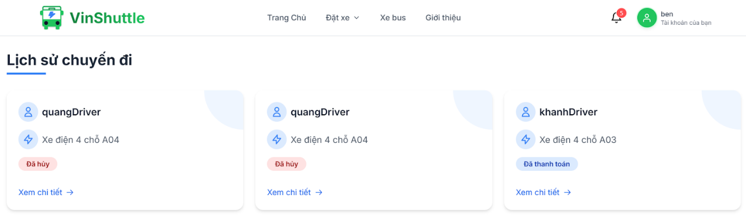
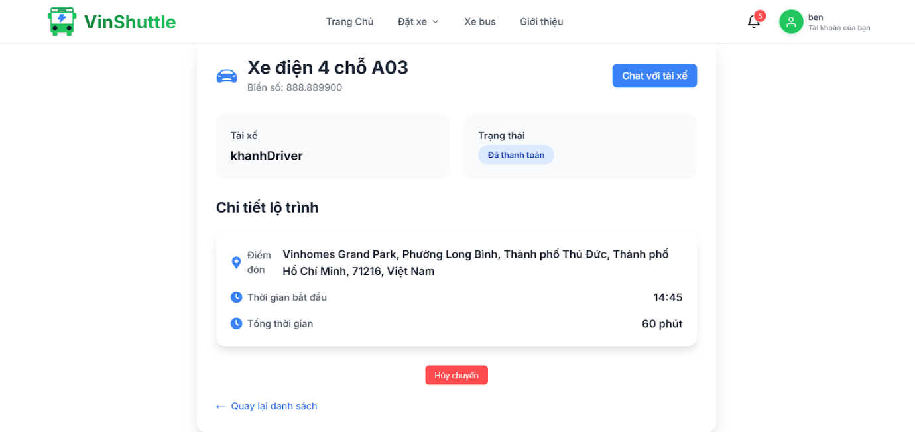
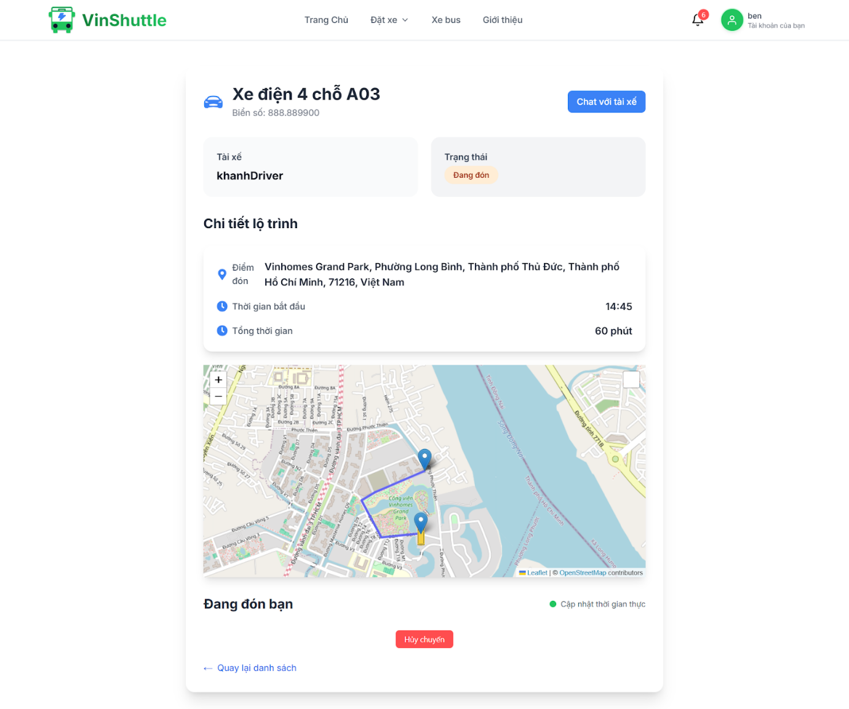
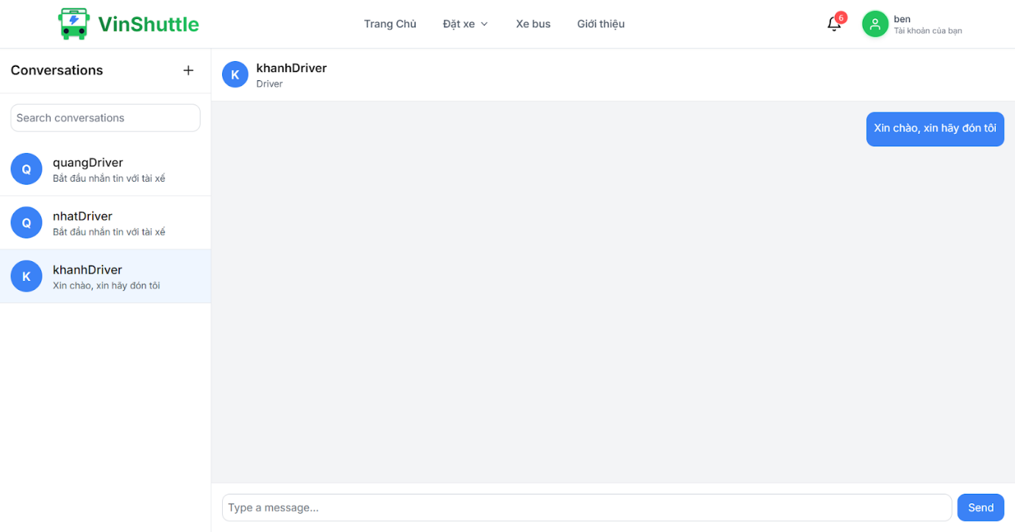
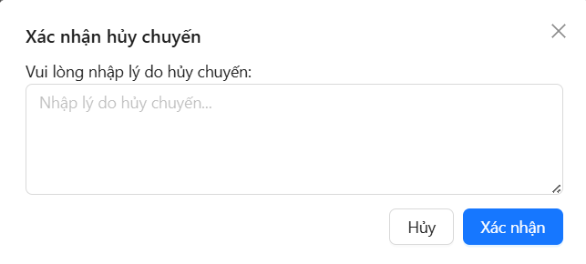
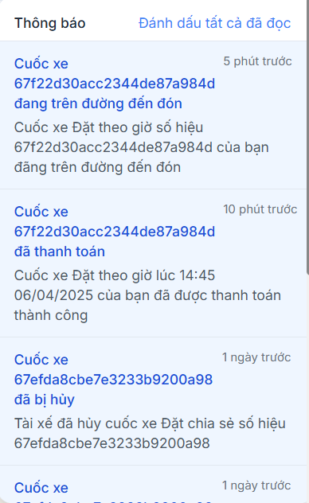
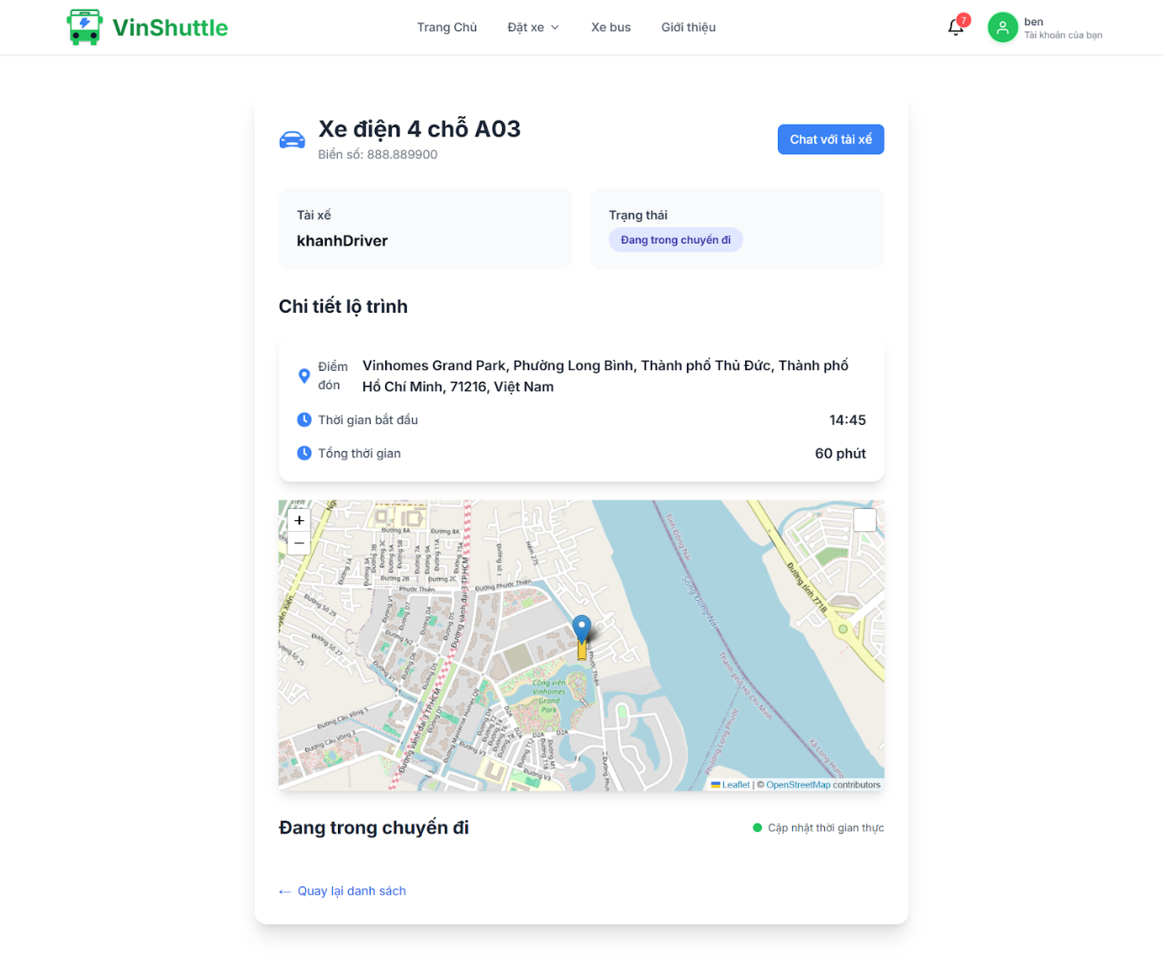
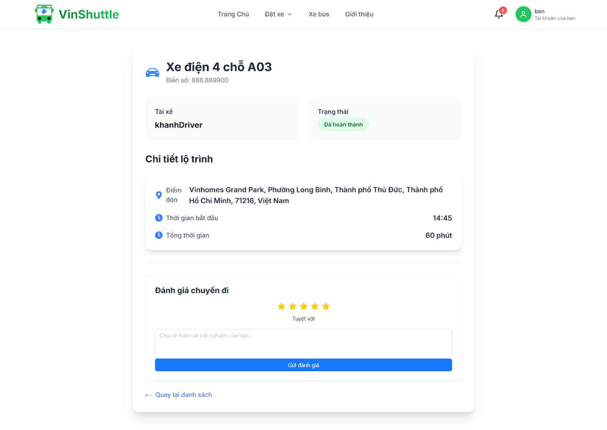

3.3 Workflow 2: Booking by scenic route
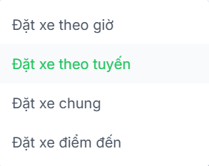
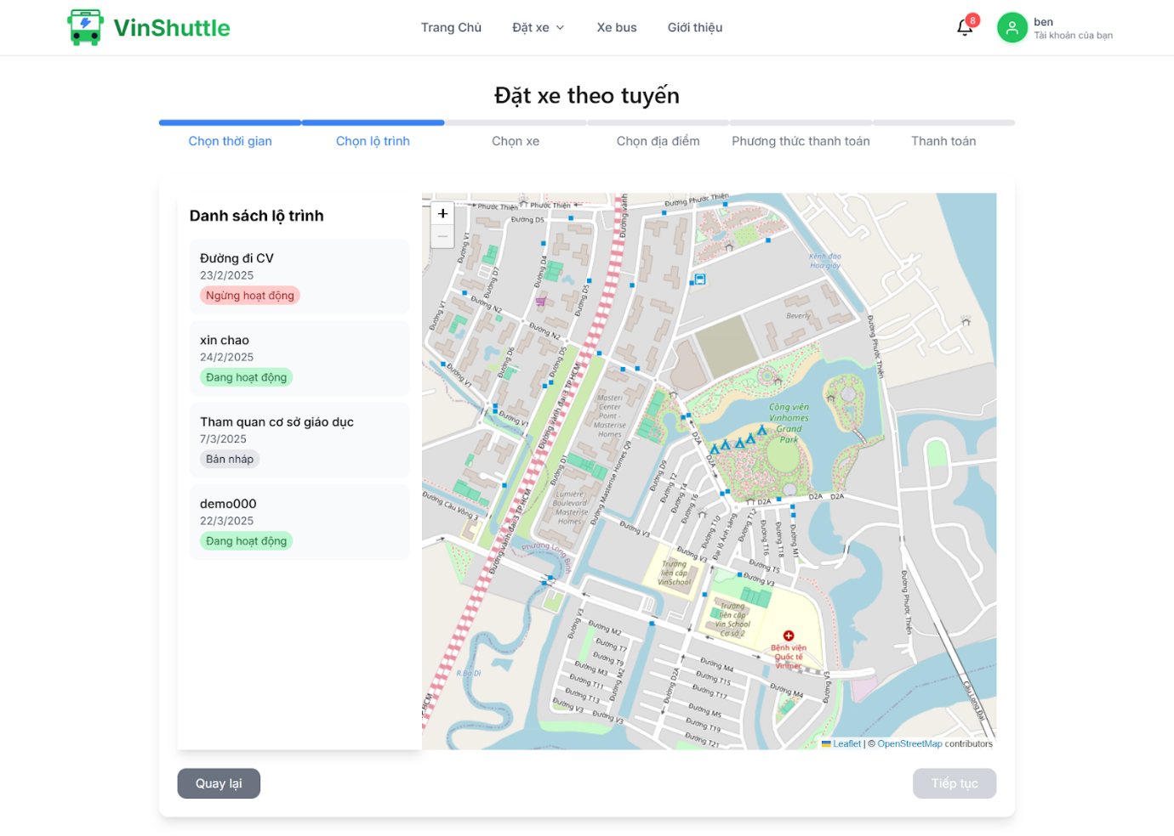
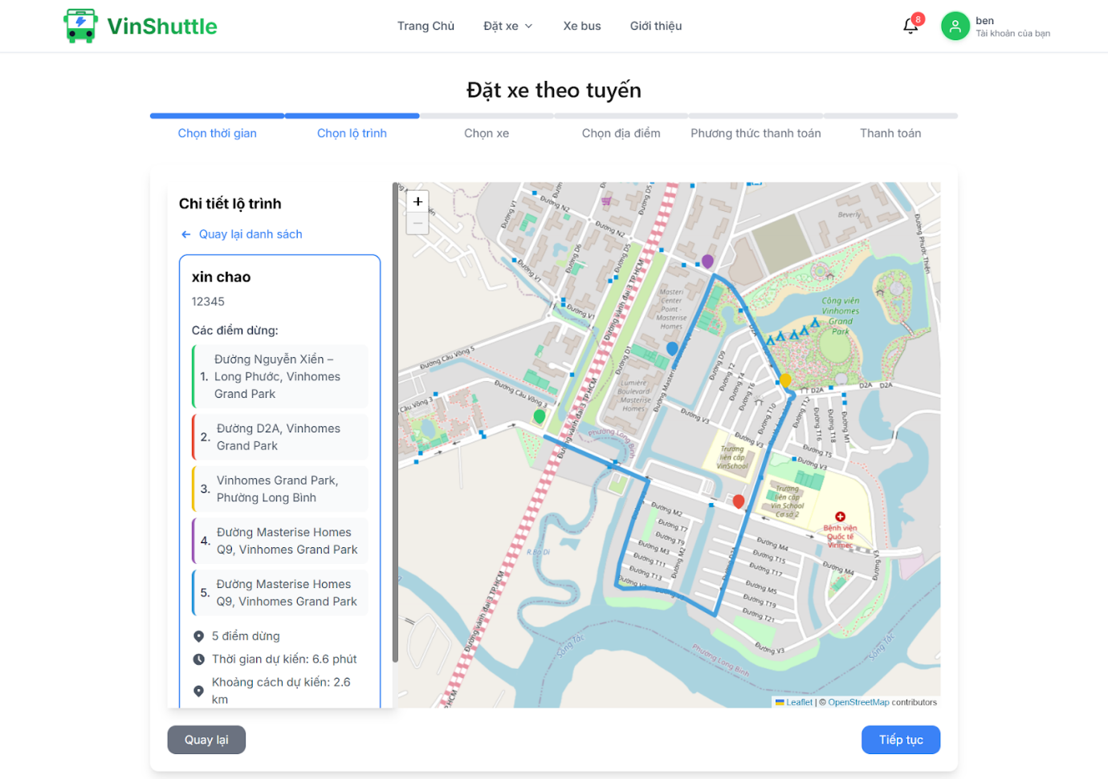

3.4 Workflow 3: Booking by destination
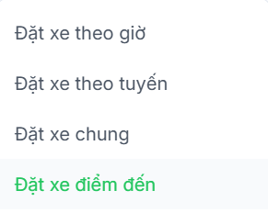
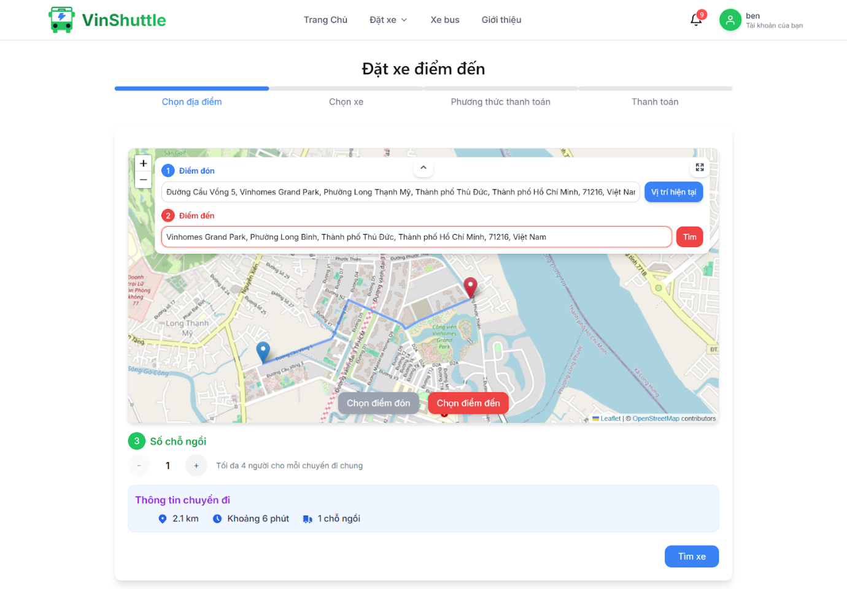

3.5 Workflow 4: Booking share
